# How to remove an internal DID

This tutorial will walk you through the steps for removing one internal DID from the VIP SW using the DaVinci Developer and DaVinci Configurator tools. We will accomplish this in a few steps:

* **Step 1:** Remove runnables and disconnect ports using the DaVinci Developer tool.
* **Step 2:** Generate templates using the configurator

|  |  |
| --- | --- |
| **Platform** | MY21 GB |
| **DID** | F0F8 |
| **Description** | SignatureBypassAuthorizationTicketInstaller (Readable,Writeable) |
| **DaVinci Configurator Version** |  |
| **DaVinci Developer Version** | 4.3.24(SP1) |
| **Prerequisites** | * Fixed or mobile Vector License * VIP source code (application project/folder) |

***Step 1: Remove runnables and disconnect ports***

Open the DaVinci Developer by navigating to the *application* project, right-clicking on *GMInfo3_5_GlobalB_MY20_AUTOSAR.dpa* the selecting *DaVinci Project Assistant* and *then Configure SWCs*. This will open the tool in a new window. If you get a prompt from the unresolved references editor, click ok and continue.

|  |  |
| --- | --- |
| **Pro-tip** | * When you’re using the tools, I recommend saving often. Make sure you save at the end when prompted, if you didn’t do it before, or you might lose your work. * If you are removing multiple DIDs at once, you can do this same step for multiple DIDs before you move on to generating the templates in the next step. * If you are a Cygwin user, cygstart is a great command for opening Windows Explorer from a Cygwin terminal. If you’ve never used it, check it out ! |

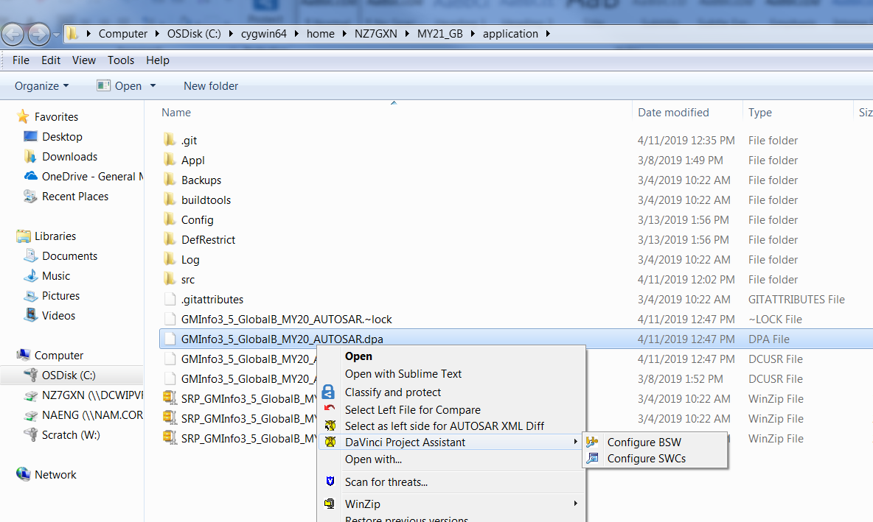

***Step 1: Remove runnables and disconnect ports (continued)***

From the Object Browser, look for Application Component Types > SWC_Internal_DIDs. When the SWC_Internal_DIDs tab opens, you will see icons on the left for options/entities you can modify.

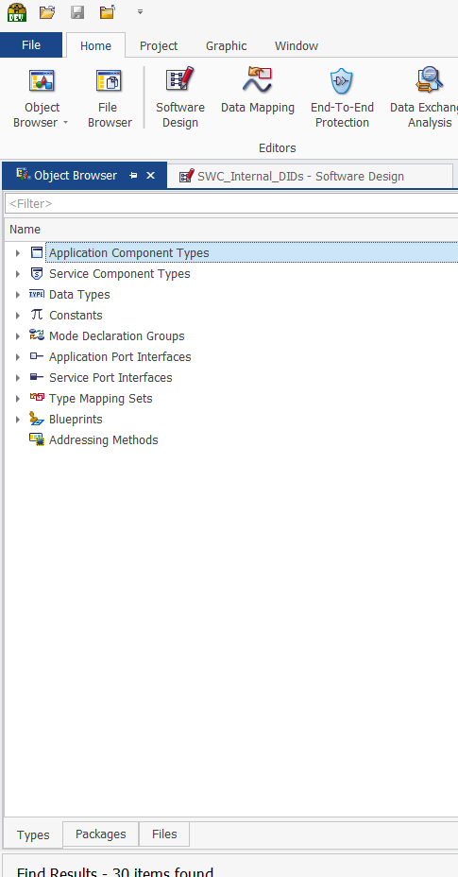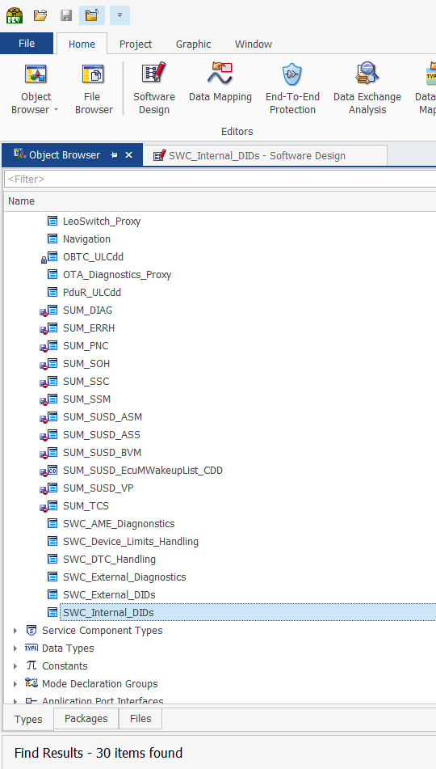



Start with Runnable entities and right-click > delete on the entity you would like to remove. Please note that you may need to do this multiple times because some DIDs are implemented with multiple runnable entities. A dialog box will open when you try to delete entities. Please confirm that the list entities in the dialog box matches the list of entities you want removed. Click Yes if it does.

Next, you will want to go to Port Prototype List. Switch to the Service Ports tab and find the DID you would like to remove in the left panel. Delete entities as needed, following the same process as with runnables.

|  |  |
| --- | --- |
| **Pro-tip** | * To check if you deleted the DID(s) entities correctly, use the Find tool to look up youd DID (enter “DID_F0F8” for example. If it worked, you will only see items you cannot delete as results. * A faster way to delete entities is to use the Find tool as above and delete all the entities that are tied to a SWC. Beware ! It’s not the recommended way but it’s fast and it works if used safely, as of 04/11/2019 using the Developer tool version used in this example. |

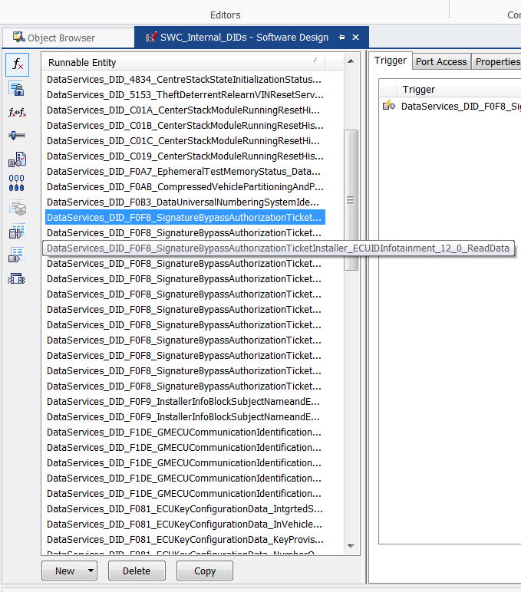

Remember to save your project before you close it.

**Step 2: Generate templates and BSW components using DaVinci Configurator Pro**

Starting back in the application project/folder in Windows Explorer, double-click on the *GMInfo3_5_GlobalB_MY20_AUTOSAR.dpa*. The program should open automatically but if it doesn’t choose DaVinci Project Assistant from the list of applications suggested when the “*Open With”* dialog box pops up. When the program is done loading, if a box pops up, select *Synchronize configuration now*.

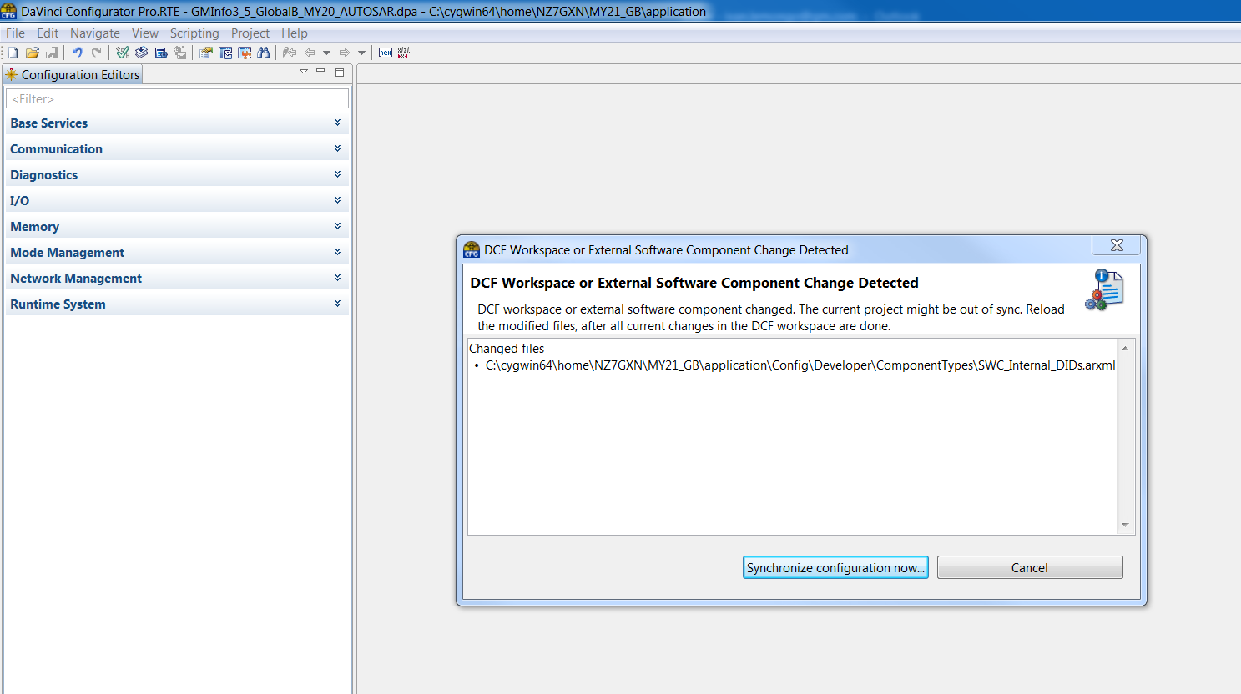

Go to Project> Project Settings> Code Generation. Begin by unchecking every box in the Code Generation section (right panel). Check only relevant components to be generated. In this case only the DCM from Diagnostics and the Rte from Runtime System are needed. Double-check that no other BSW components are selected, this wouldn’t be fatal, but it might make it hard to verify our code changes later.

Go to Project>Project Settings> SWC Templates and Contract Headers. Ensure that only the needed SWCs are checked for generation. As above, you could generate more than you need but it’s not recommended. In this case, we will pick the SWC_Internal_DIDs component. Please keep in mind that we are selecting code generation options, but we are not ready to generate BSW or SWC code/templates yet. The DID removal process is not yet complete.

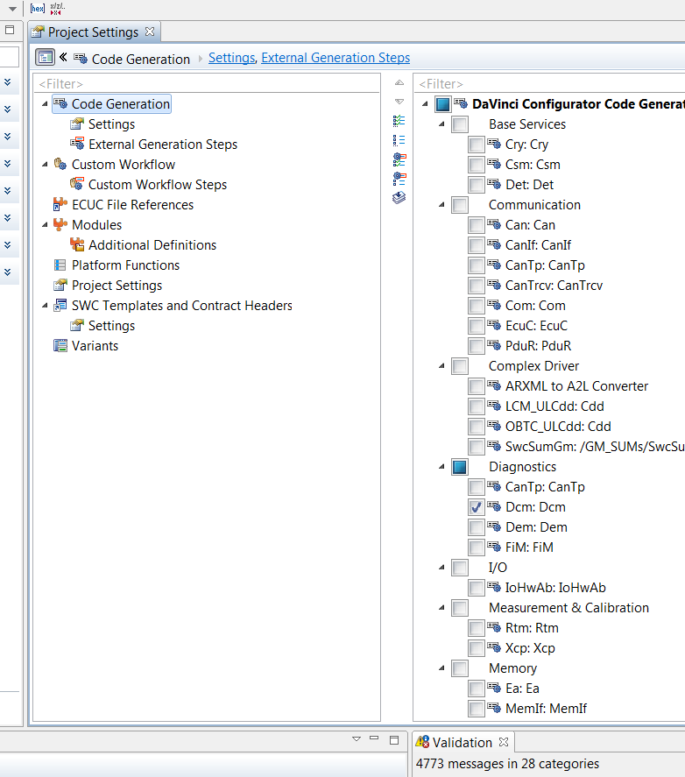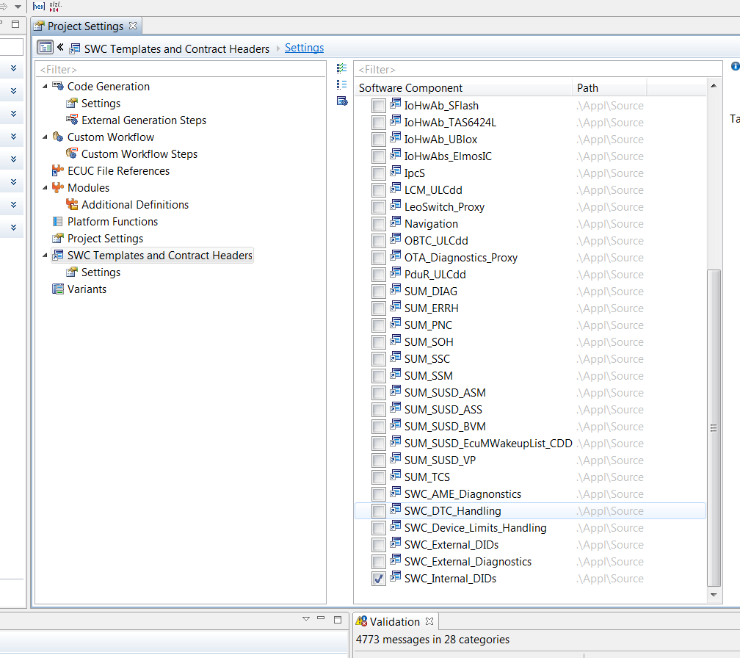

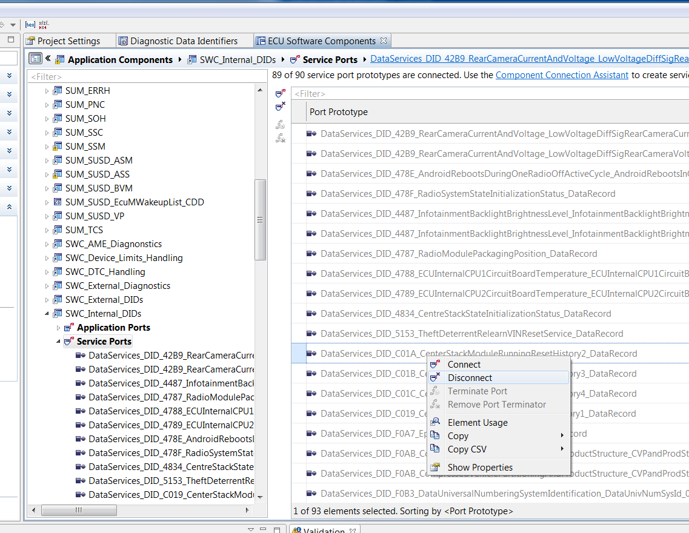Let’s remove the DIDs using Configurator Pro. We will disconnect the DIDs service ports. Go to Configuration Editors>Runtime System> ECU Software Components>Application Components> SWC_Internal_DIDs>Service Ports. Find your DID on the right, right-click > disconnect. Please note that you may not find your DID in the list. This is unusual but it’s not a show stopper. Continue as planned and confirm if the process worked by testing.

Go to Configuration Editors> Diagnostics> Diagnostic Data Identifiers. Enter your DID inside the top right filter and uncheck the ‘Used’ column. Be sure to synchronize by clicking ‘synchronize now’ at the bottom of the window (yellow pop-up warning).

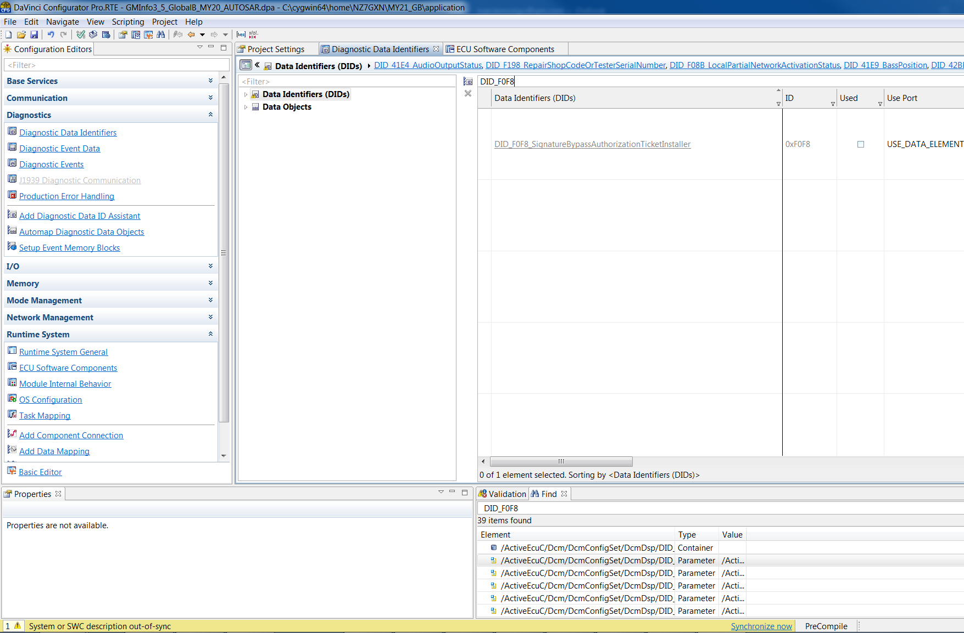

We are almost ready to generate. Go to the validation tab and look for error warnings. If you see a ‘Connector Prototype Inconsistent’ warning, right-click> Remove inconsistent connectors.

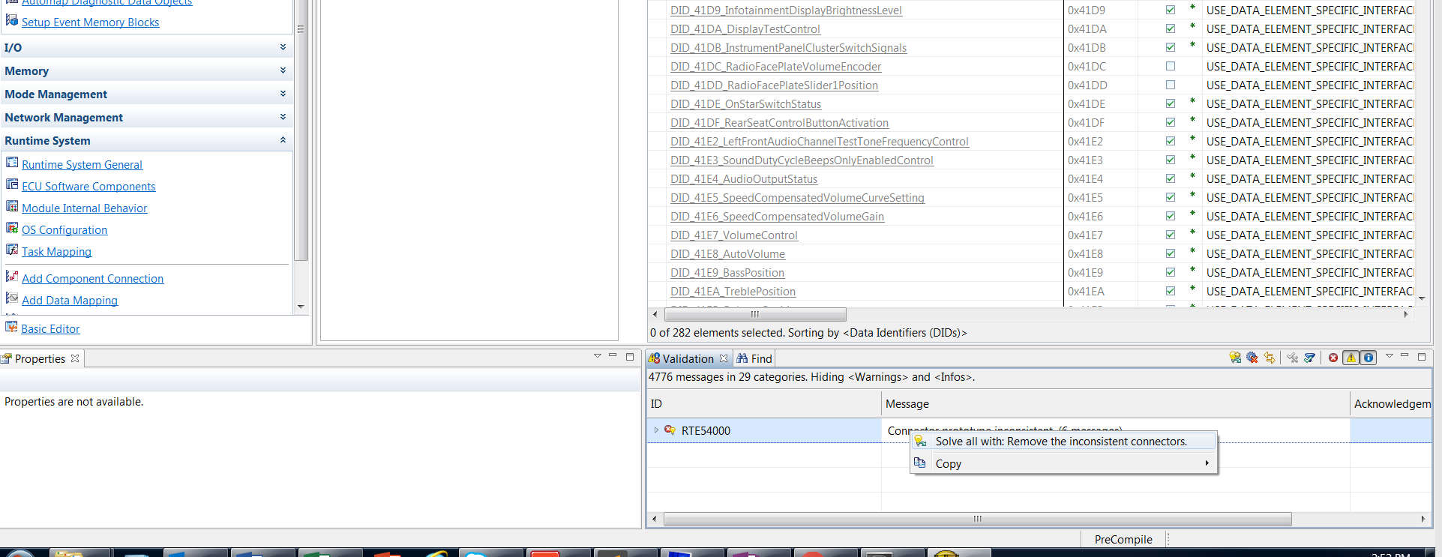

There will be other warnings you might be tempted to resolve. Unless they are related to the DID you are removing, do not resolve them! Resolving warnings, you do not understand might result in unpredictable behavior and might make it difficult to review your code changes. Warnings are different from errors in that the code generator will fail if there are errors, but it might proceed with known warnings that are not due to your changes.

You can now generate code. Let’s begin by generating the SWC templates. Go to ‘Generate Software Components Template …’ (see icon below in red).

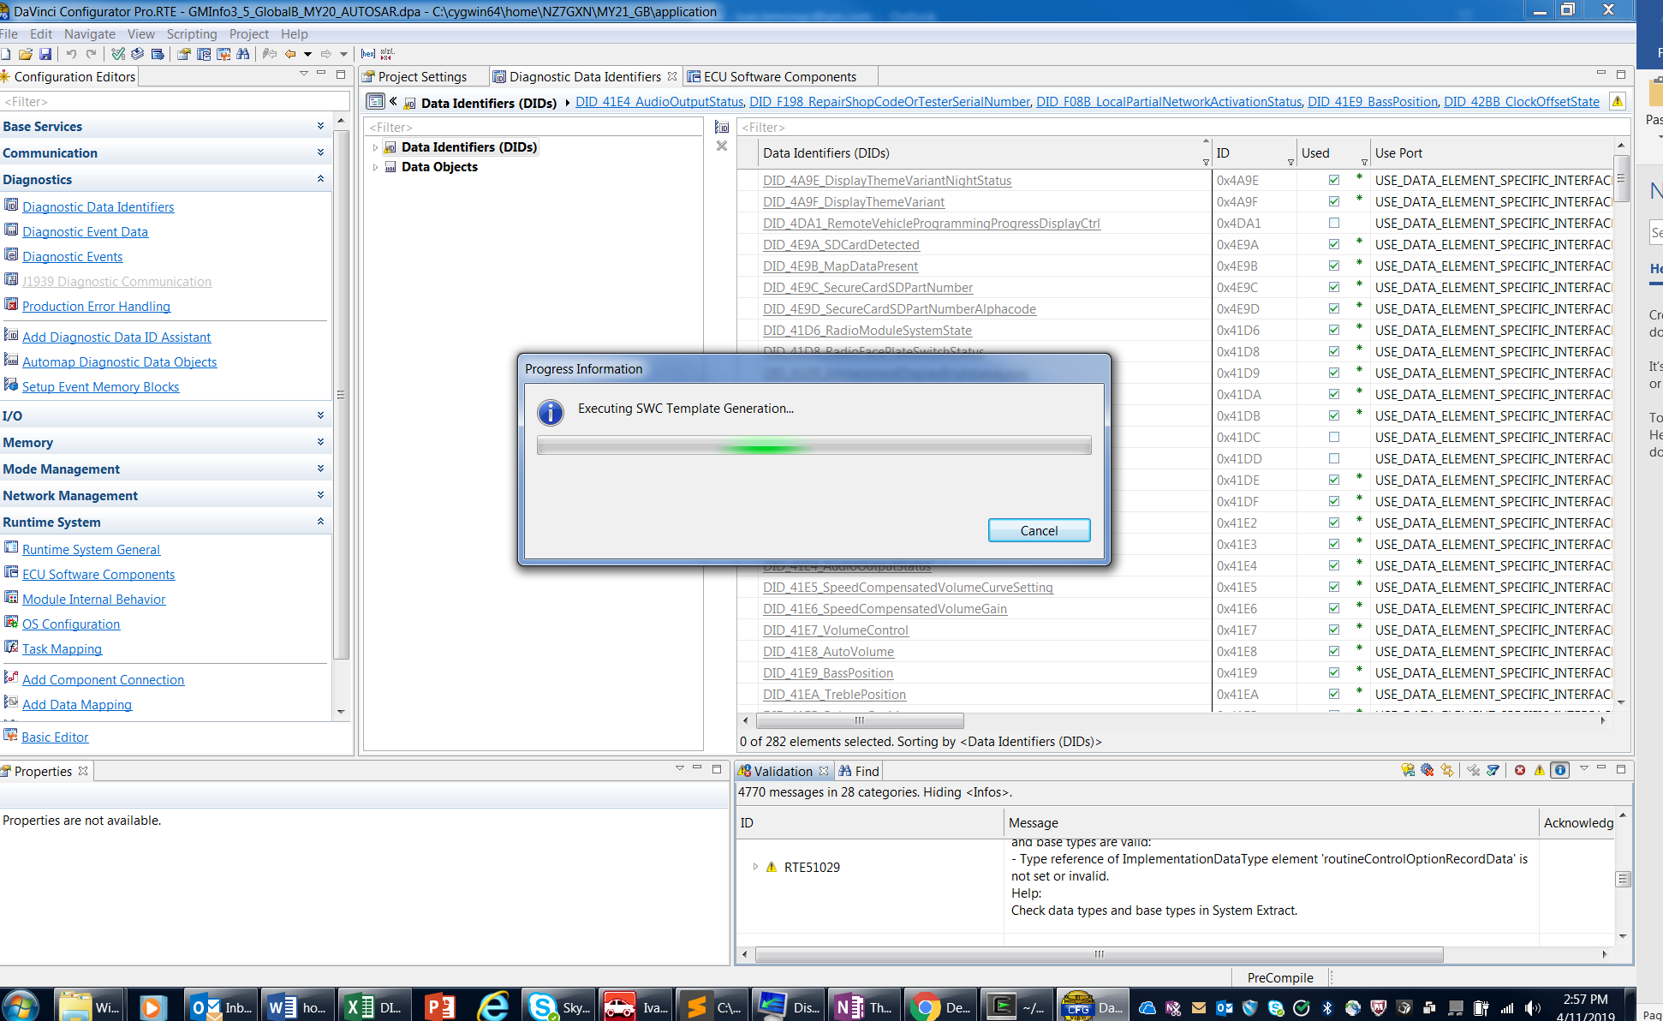

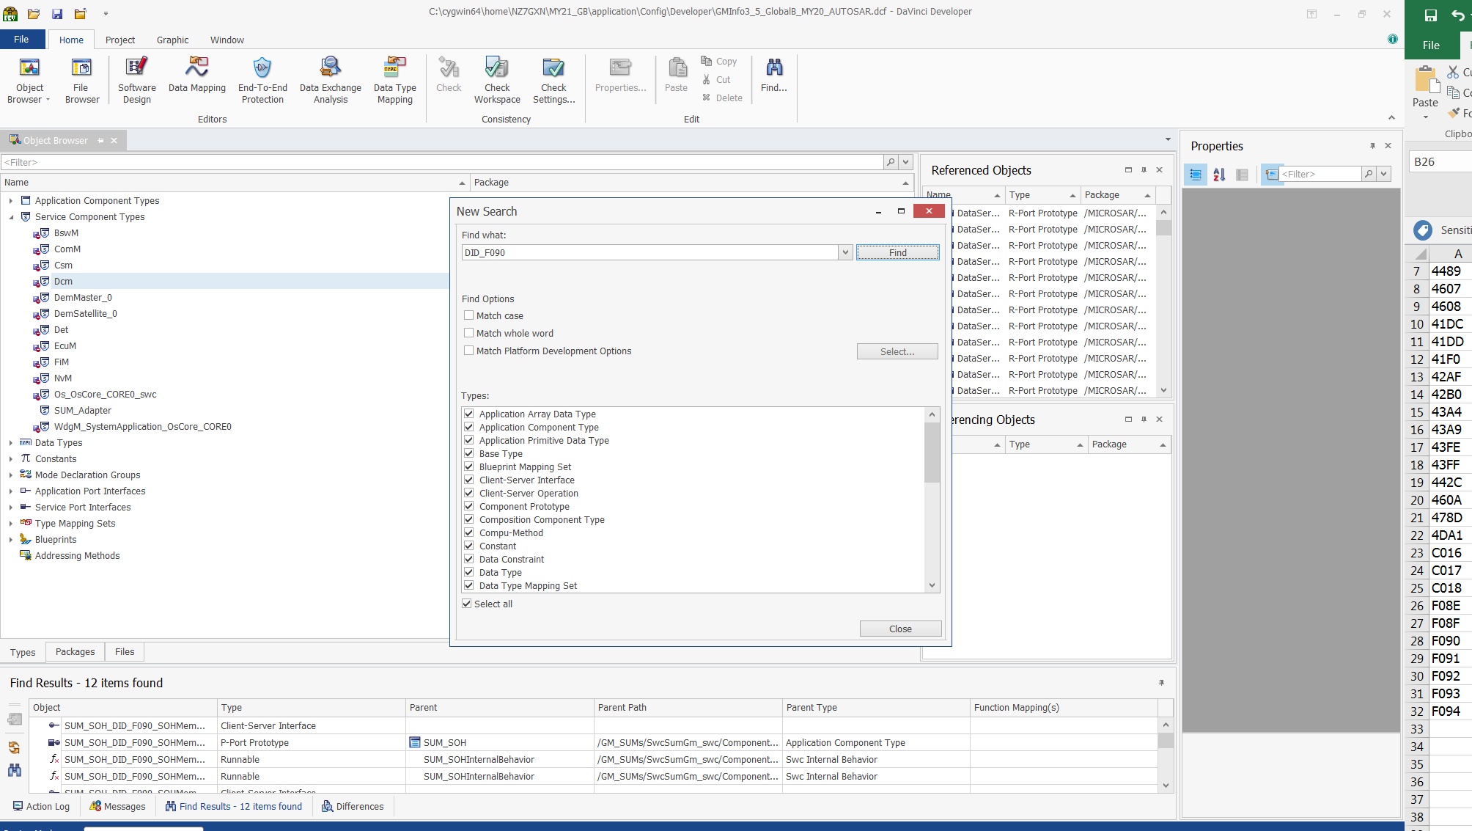

Finally, you can generate BSW components by clicking the “generate” button (see icon in green circle above). If the generation process is successful, you are done with the DID removal process. You will want to carefully review all the files that were changed you removed the DID and ensure that no unexpected changes were made. DO NOT neglect or skip this last step! Developers have reported several times that unexpected/unwanted changes were made by the VECTOR tools used in this tutorial. You will want to review and delete those changes as needed. Additionally, be sure to test to confirm that the DID was removed. As of the day this tutorial was first written, the expected response to reading a DID that was removed is an NRC 31 (Negative Response Code 31 = Request Out of Range).